Project: Woodson Park Academy & YMCA-ELC
Week Ending: August 23rd, 2019

THIS WEEK:
- Waiting on French drain design / feedback due to water
- Continued building pad
- Continued site concrete haul off
- Hauled in fill material

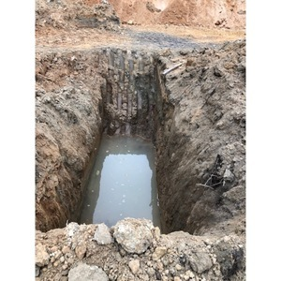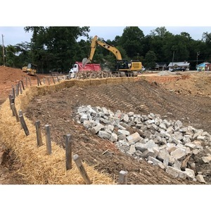

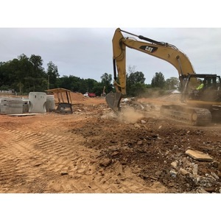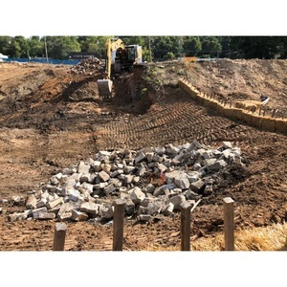

NEXT WEEK – August 26 thru August 30:
- Grading continues
- French drain design
- Concrete haul off
- Fill haul in

PAYMENT STATUS:
- Gmp#1 $3,703,488.00
  - Paid to date amount $0.00
- GMP#2 $28,686,295.00
  - Paid to date amount $0.00

SCHEDULED DATE OF SUBSTANTIAL COMPLETION
- WPA – September 28, 2020
- YMCA-ELC - September 16, 2020

PREPARED BY:
- Matt Dauber, Carroll Daniel Construction Co.

